Ideation Phase
Brainstorm & Idea Prioritization

Date | 15 July 2026
Team ID | Team 1
Project Name | UNESCO World Heritage Sites Analysis Using Tableau
Maximum Marks | 4 Marks

Brainstorming was conducted to identify possible features and analytical approaches for the UNESCO World Heritage Sites Analysis dashboard. The ideas were evaluated based on feasibility, user value, and implementation priority to determine the most effective solution.

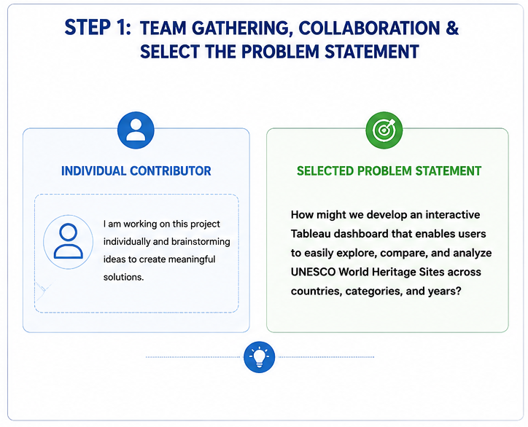

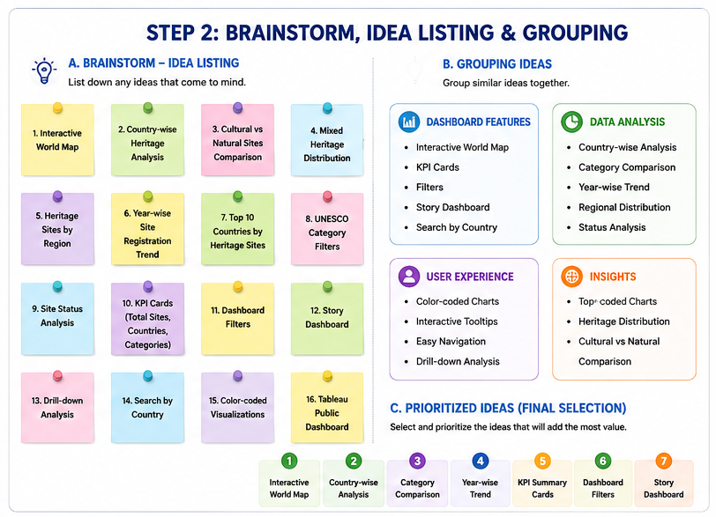

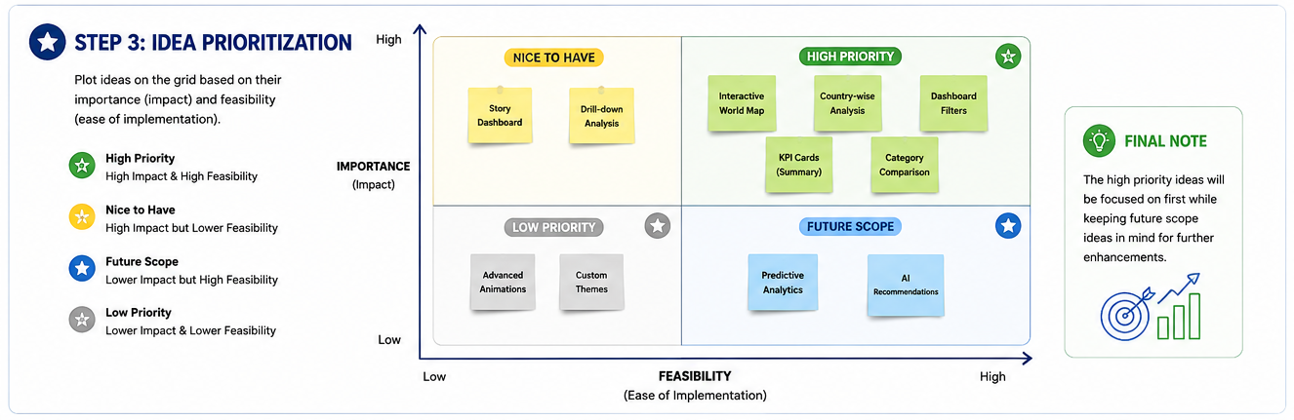
Based on the prioritization process, high-impact and feasible features such as the interactive world map, country-wise analysis, KPI cards, dashboard filters, and category comparison were selected for implementation in the Tableau dashboard.

